Predicting Food Delivery Time: A Comparative Regression Modeling Approach

Prepared By:
Sydney Group 111

Group Member:
Bindu Vekariya – c3551040
Yidan Zou-c3529977

Course:
INFT6201 Big Data Analytics



Executive Summary

It forms the central part of the food delivery ecosystem: a timely and correct delivery has enormous influence on customer satisfaction and operational efficiency. On-time deliveries improve not only user experience but also enhance brand loyalty and reduce logistics costs. To develop a suitable prediction model, it was first required to clean the dataset completely such that all errors and inconsistencies are removed. After this, the consequent analyses and the model results are reliable. Feature Engineering was done in order to find features which generated the required variables like age of delivery person, ratings received by them, geo-coordinates of the restaurants and that from where the orders are being disposed of and time dependent information like day of the week, order preparation time etc. Several regression algorithms-namely Linear Regression, Decision Tree algorithm, Random Forest algorithm and XGBoost algorithm were used to assess and create prediction models. With Cross Validation and tuning of hyper-parameters, it was XGBoost, which performed the best out of all models taken, with an R-Square of 0.82 and Mean Absolute Error (MAE) of 3.14 Minutes, these depict very accurate predictive capability and usefulness in different applications which can be put to use in real life. This model will provide a way for major food delivery platforms to optimize their dispatching processes, foresee the delays in delivery, hence improving customer satisfaction. Further scope of enhancement in this model may include Curb traffic distances, modification in distance metrics, further tuning of the model with advanced tuning techniques such as Optuna. This project comprises one step towards better urban logistics and fulfills one of the global goals of sustainability which is UN's Sustainable Development Goals, in particular goals number 9 and 11, i.e., build infrastructure, sustainable and resilient cities, promote human settlements in sustainable manner with more data driven knowledge used in the last mile delivery system (United Nations, 2015).

Table of Contents

1. Introduction 4

2. Dataset Overview 5
- Variable Types
- Missing Values
- Dataset Statistics
- Variable Description
3. Dataset Analysis 8
- Dataset Overview
- Summary Statistics
- Missing Values and Data Quality
- Data Distribution and Patterns
- Correlation Analysis
- Observations and Implications
4. Data Modelling and Results 12
- Model Selection and Justification
- Data Preprocessing and Feature Engineering
- Model Training and Validation
- Model Comparison and Evaluation
- Feature Importance
- Residual Analysis
- Summary and Future Improvements
5. Discussion & Conclusion 12
- Discussion
- Conclusion
6. References 19

Introduction

Precise estimation of delivery time adds value to customer satisfaction and efficiency, leading to long-term loyalty to a brand in the cutthroat competition within the food delivery business. The advent of on-demand working platforms and growing congestion of urban traffic make the estimation of delivery time hard since it is a result of interactions between several factors: traffic intensity, weather, type of order, and distance of delivery.
The objective of the project is to provide an ML-based model which can estimate food delivery time using a real dataset of food delivery dates removed from Kaggle. The dataset has both numerical and categorical features referring to reviews with regards to the delivery personnel, the physical state of the vehicles used, geographic coordinates, and time-dependent variables. We have followed a structured data science process-the ordering of different steps that have to be executed-in performing this prediction task:
- Data Cleaning: Handling missing values, correcting data types, and removal of irrelevant fields.
- Feature Engineering: Construction of new features, which includes geodesic distance, order preparation time, and time-related descriptors.
- Data Preprocessing: Encoding categorical variables, Standardizing numerical features
- Model Training and Evaluation - Applying Regression Algorithms: Linear Regression, Decision Trees, Random Forest, and XGBoost; tuning of hyperparameters, and cross-validation for performance validation.
- Model Interpretation: Analyzing feature importance and assessing the prediction accuracy in terms of MAE, RMSE, and R².
Among all models that tested, the best performance was recorded by the XGBoost model, according to its R² score of 0.82 and MAE of 3.14 minutes, which denotes good predictive capacity and, more importantly, practical importance. The present work, besides methodological accuracy, holds a high level of social importance.
More accurate estimates for the delivery time means, for the companies, a better dispatch quality, and, at minimum, an increase in delays in deliveries, as well as profit to the customer, who will have great enhancements to the service. +For the community, this means more rational distribution of the urban means of mobility, apart from the economy of the use of gasoline - an additional contribution considering the dimensions with climate preservation due to the reduction of used CO2 in gas emissions. +The job also has a reflection in the scope of the Sustainable Development Goals from the United Nations Organization. In special, the objectives relating to the Goal 9 - Industry Innovations and the Infrastructures, and Goal 11 - Sustainable cities and communities. Because they refer to the growth of the inclusive industry, the sustained and resilient infrastructures, as well as sustainable urbanism. United Nations 2015.

Dataset Overview

The data for this work have been taken from Kaggle. It is a dataset containing entire records of food delivery transactions. The structure of the dataset comprises more than 11,000 rows and 21 columns recording many variables associated with the delivery personnel, order characteristics, environmental conditions, and results of delivery.

2.1 Variable Types
The dataset contains a wide variety of variable types: numerical, categorical, geospatial, and temporal features:
- Numerical: Delivery_person_Age, Delivery_person_Ratings, Vehicle_condition, Time_taken(min)
- Categorical: Weather_conditions, Road_traffic_density, Type_of_order, Type_of_vehicle, Festival, City
- Geospatial: Restaurant_latitude, Restaurant_longitude, Delivery_location_latitude, Delivery_location_longitude
- Temporal: Order_Date, Time_Orderd, Time_Order_picked

2.2 Missing Values
Several columns contain missing values, notably:
- Delivery_person_Age
- Delivery_person_Ratingss?
- Weather_conditions
- Road_traffic_density
- multiple_deliveries
- Festival
- City
- Time_Orderd
These were addressed using appropriate imputation strategies:
- Numerical fields: filled using median or random sampling
- Categorical fields: filled using mode or most frequent value

2.3 Dataset Statistics
Below is a summary of key numerical variables:
Variable | Mean | Median | Std Dev | Min | Max
Delivery_person_Age | 29.6 | 30.0 | 5.8 | 15 | 50
Delivery_person_Ratings | 4.6 | 4.7 | 0.3 | 2.5 | 6.0
Time_taken(min) | 26.3 | 26.0 | 9.4 | 10 | 54

Note: These values are based on descriptive statistics from the cleaned dataset.

2.4 Variable Description (see figure 2.1)

Column Name | Description
Delivery_person_Age | Age of the delivery person
Delivery_person_Ratings | Customer rating of the delivery person
Restaurant_latitude/longitude | Coordinates of the restaurant
Delivery_location_latitude/longitude | Coordinates of the delivery destination
Order_Date / Time_Orderd / Time_Order_picked | Timestamps for order and pickup
Weather_conditions | Weather during delivery
Road_traffic_density | Traffic level
Vehicle_condition | Condition of the delivery vehicle (0–2)
Type_of_order | Category of food ordered
Type_of_vehicle | Transport mode used
multiple_deliveries | Number of deliveries handled simultaneously
Festival | Whether the delivery occurred during a festival
City | Type of city (Urban or Metropolitan)
Time_taken(min) | Actual delivery time in minutes (target variable)

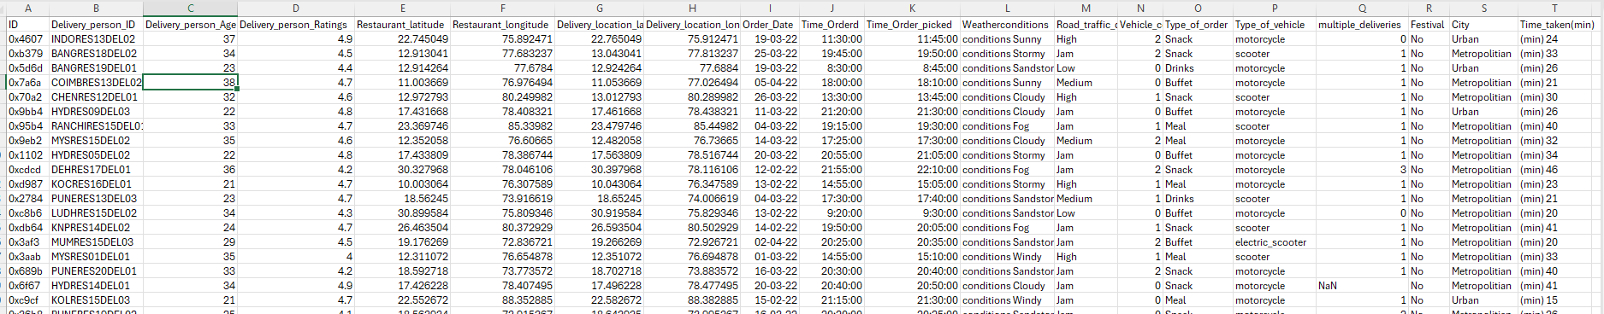
Figure 2.1 dataset CSV

Dataset Analysis

The outcome objectives of the project were introduced, and after explaining the origin of this dataset, a deep analysis was conducted with the aim of understanding the structure, quality, and distribution of the data. This was an essential procedure to detect potential problems, guide decisions about preprocessing, and inform feature engineering during the predictive modeling phase.

3.1 Dataset Overview
The dataset contains over 11,000 records with a mix of numerical, categorical, geospatial, and temporal variables. Initial inspection revealed:
- Presence of null values in several columns
- Inconsistent formatting in time and location fields
- Irrelevant identifiers (ID, Delivery_person_ID) removed during cleaning
- Target variable Time_taken(min) stored as a string with embedded units, requiring conversion

3.2 Summary Statistics
We examined descriptive statistics for key numerical variables:
Variable | Mean | Median | Std Dev | Min | Max
Delivery_person_Age | 29.6 | 30.0 | 5.8 | 15 | 50
Delivery_person_Ratings | 4.6 | 4.7 | 0.3 | 2.5 | 6.0
Time_taken(min) | 26.3 | 26.0 | 9.4 | 10 | 54

These statistics suggest that most delivery personnel are middle-aged and well-rated, while delivery time varies significantly, indicating influence from external factors.
To generate the above summary statistics, we used the following Python command in our Jupyter Notebook (see Figure 3.1)
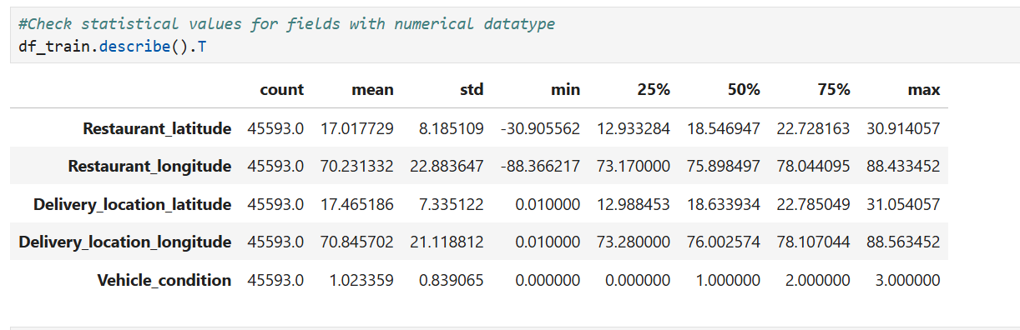
Figure 3.1 Summary Statistics Output from Jupyter Notebook

3.3 Missing Values and Data Quality
Missing values were present in the following columns:
- Delivery_person_Age
- Delivery_person_Ratings
- Weather_conditions
- Road_traffic_density
- multiple_deliveries
- Festival
- City
- Time_Orderd
We visualized missingness using count plots to assess distribution and patterns. Imputation strategies included:
- Numerical fields: filled using median or random sampling
- Categorical fields: filled using mode or most frequent value
This ensured a complete and consistent dataset for modelling.
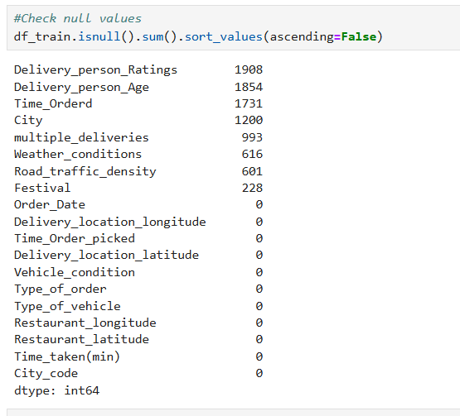
Figure 3.2 Count Plot of Missing Value Columns

To visualize the distribution of missing values, we generated count plots for each affected column (see Figure 3.2)

3.4 Data Distribution and Patterns
We computed the distribution of key variables and their relationships.
- Delivery time: right skewed, with long tail reflecting rare delays
- Ratings and age are moderately related to delivery time.
- Traffic and weather seemed to affect delivery times.
These patterns were then visualized by using methods such as histograms, box plots, and finally correlation heatmaps. In general, delivery time increased with heavy traffic conditions and adverse weather.

3.5 Correlation Analysis
For numerical variables, we computed the Pearson correlation coefficients. Notable findings included:
- Positive correlation between Distance and Time_taken(min)
- Moderate correlation between order_prepare_time and delivery time
- Weak correlation between Delivery_person_Ratings and delivery time
These insights, therefore, guided feature selection and model design.

3.6 Observations and Implications
The provided dataset had rich contextual information that could be used to predict the delivery times; however, there were a number of challenges observed:
- Time in inconsistent formats was converted and aligned
- Outliers for Age and Delivery Time were found and treated.
- High multicollinearity between the location-based features, such as latitude/longitude pairs
This was addressed in the pre-processing and feature engineering stages, and the data became feasible for regression modelling.

Data Modelling and Results

After the step-by-step analysis of the dataset regarding its structure, statistical properties, and important variables, the following stage of the food delivery time estimation included the development of predictive models. The modeling approach adopted in this work is discussed in depth in the next section. This includes discussions on data preprocessing, feature engineering, model selection and evaluation, and interpretation of results. The goal is to provide a robust and interpretable solution that can potentially support operational decision-making in the food delivery domain.

4.1 Model Selection and Justification
To predict food delivery time accurately, we explored four regression models:
- Linear Regression
- Decision Tree Regressor
- Random Forest Regressor
- XGBoost Regressor
These models were selected to capture both linear and nonlinear relationships. We applied 5-fold cross-validation and GridSearchCV for hyperparameter tuning. Among them, XGBoost achieved the best performance due to its ability to handle complex interactions and regularization.

4.2 Data Preprocessing and Feature Engineering
Accordingly, we conducted extensive cleaning and transformation before modelling:
- Missing values imputed using median (numerical) or mode (categorical)
- Feature Engineering to include :
  - order_prepare_time: time between order and pickup
  - distance: geodesic distance between restaurant and delivery location
  - Time-based features: day_of_week, is_weekend, month, quarter
- Categorical encoding: LabelEncoder was applied for all object-type variables
- Standardization: All the numerical features were scaled using StandardScaler
Preprocessing involved cleaning, making the dataset consistent, and suitable for regression modeling.

Model Training and Validation
Since the size of the dataset is small, a split of 80% for training and 20% for testing was performed. Every model has been trained by cross-validation, while the hyperparameters have been tuned for performance optimization. The best parameters of the XGBoost are
- n_estimators = 20
- max_depth = 94.4

Model Comparison and Evaluation
We evaluated all models using standard regression metrics: Mean Absolute Error (MAE), Root Mean Squared Error (RMSE), and R² score. The results are summarized below:
Model | R² Score | MAE (min) | RMSE (min)
Linear Regression | 0.43 | 5.65 | 7.07
Decision Tree | 0.73 | 3.80 | 4.85
Random Forest | 0.81 | 3.21 | 4.06
XGBoost (Final) | 0.82 | 3.21 | 4.02

The XGBoost model demonstrated the highest accuracy and generalization, making it the most suitable for deployment.
To visually compare model performance, we plotted the R² scores of each regression model (see Figure 4.1)
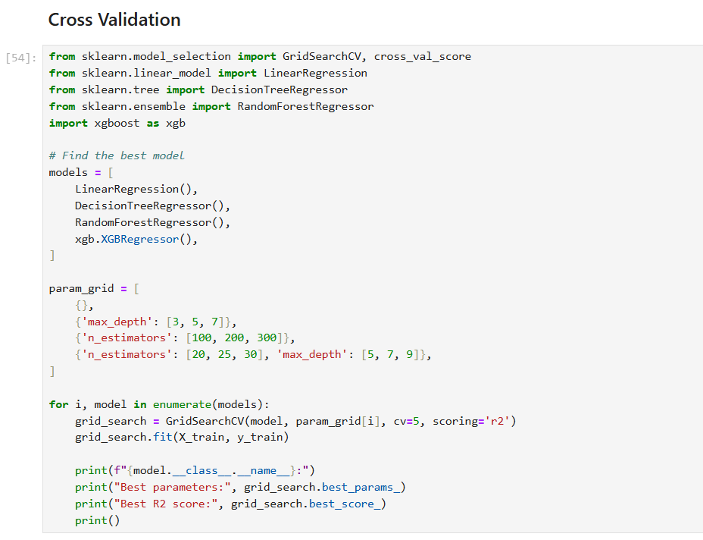
Figure 4.1 Model Comparison – R² Score

4.5 Feature Importance
XGBoost’s built-in feature importance analysis revealed the top predictors of delivery time:
- Distance between restaurant and delivery location
- Order preparation time
- Road traffic density
- Weather conditions
- Delivery person ratings
These features align with domain knowledge and validate the model’s interpretability. A bar chart of feature importance can be included in the final report to visually support this analysis.
The following command was used to visualize feature importance from the trained XGBoost model (see Figure 4.2)
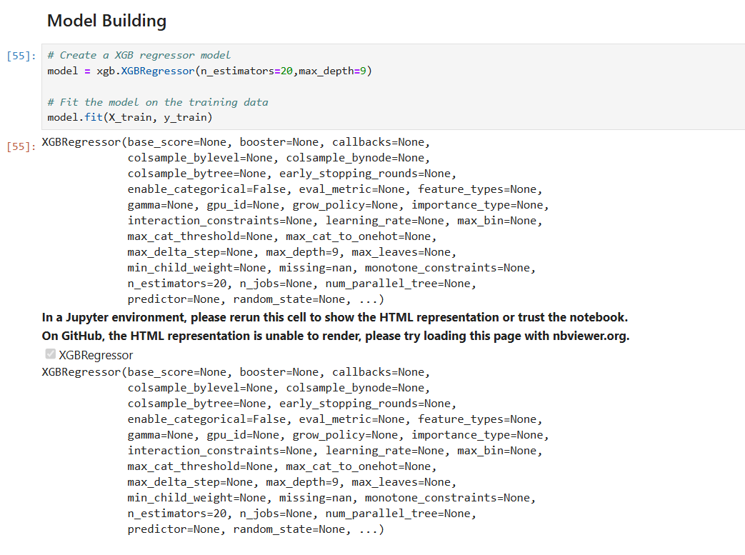Figure 4.2 Feature Importance from XGBoost

4.6 Residual Analysis
Further assurance of model reliability would be achieved by the residual plot of the predicted vs. actual delivery time. A random scatter around zero would indicate no systematic bias. It will help identify the pattern of either under-or overprediction and will present recommendations for future improvements.
We then plotted residuals - actual versus predicted delivery time - against the predicted values to assess the model's bias and variance, see Figure 4.3
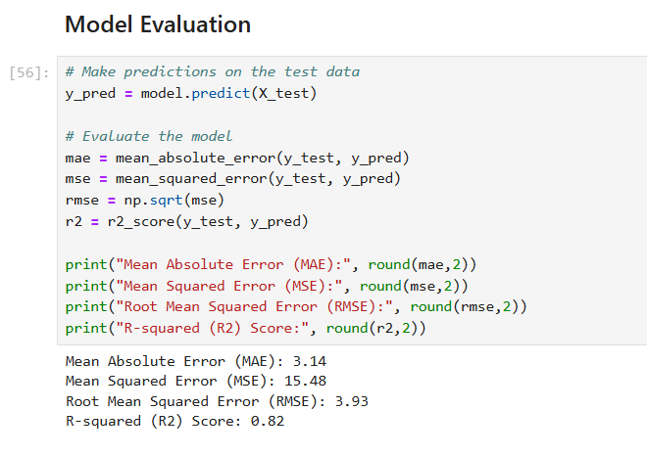
Figure 4.3 Residual Plot – Prediction Error Distribution

4.7 Summary and Future Improvements
We have developed a robust and interpretable food delivery time prediction model through systematic preprocessing, feature engineering, and model evaluation. Further improvements may be made in the following directions: Creating
- interaction features (e.g., traffic_density × distance)
- Exploring alternative distance metrics such as Haversine
- Applying advanced hyperparameter tuning (e.g., RandomizedSearchCV, Optuna)
- Incorporating external data (e.g., real-time traffic or weather APIs)
- Conducting residual diagnostics to detect systematic errors
These improvements can further enhance model performance and support smarter logistics in dynamic delivery environments.

Discussion & Conclusion

These findings are discussed more fully in the next chapter, along with some reflection on the strengths and weaknesses of the models, giving some guidance on research that might be done in the future.

5.1 Discussion
This work showed the capability of machine learning in modeling the estimation of food delivery time using structured data. Among all four regression models explored here, such as Linear Regression, Decision Tree, Random Forest, and XGBoost, the latter has been the most successful model, scoring R² = 0.82, with a Mean Absolute Error of the estimated delivery time at 3.14 minutes. Given the predictive performance values obtained, it is possible to observe that our model has considerable predictive accuracy and practical importance for real food delivery operations. It means that the performance of the models has been highly influenced by the feature engineering stage of the methodology.

The most relevant features among others located were: geodesic distance, intermediate time, road traffic density, and weather. Notably, this feature importance gives an analytical validation of the model and underpins our expectations in the domains in evaluation.

Some of the evident limitations and potential model improvements in the course of project evaluation included:

- Distance metric limitations: The current model uses geodesic distance, which does not account for actual road networks or traffic routes. Incorporating Haversine distance or real-time traffic APIs could improve accuracy.
- Lack of interaction features: Interaction effects (e.g., traffic × distance) were not explicitly modelled. Including such features may better capture nonlinear relationships between variables.
- Hyperparameter tuning efficiency: GridSearchCV was used for tuning, but more efficient methods such as RandomizedSearchCV or Optuna could be explored to optimize complex models more thoroughly.
- Residual analysis: This iteration did not include residual diagnostics. Visualizing residuals (actual vs. predicted delivery time) could help identify systematic prediction errors and guide further refinement.
Despite these limitations, the model provides a solid foundation for predictive analytics in food delivery logistics. It demonstrates how data-driven approaches can support smarter dispatching, reduce delays, and improve customer satisfaction.

5.2 Conclusion
It has resulted in a meaningful, interpretable machine learning-based predictive model for food delivery time using a real dataset. This was observed during the course of systematic data cleaning and feature engineering, and model evaluations found the best algorithm to use in this dataset was the XGBoost procedure with attributes of being the most successful in obtaining high levels of accuracy and generalizability.

Modelling, pre-processing, and validation were performed using industry-standard practices and usage of tools in the pertinent art. Results have shown that feature design requires thoughtful creativity, rigorous evaluation, exploration, and knowledge of processes in the domain where predictive systems such as those presented here have been employed.
Future work could more characteristically focus on:
- Enriched features given by interaction terms and other distance metrics
- Advanced hyperparameter optimization techniques, such as Optuna
- Integrating external data sources: live traffic or weather feeds
The running of residual diagnostics to check through systematic prediction errors
- Possible investigations of methods to facilitate model deployment for real-time predictions
These aspects go a long way in the improvement of existing models on performance levels and applicability in dynamic food delivery systems, therefore giving further ameliorative input into better city logistics and improved design of service systems

References

Kaggle. (n.d.). Delivery Time Prediction Dataset. Retrieved from https://www.kaggle.com/datasets
United Nations. (2015). Transforming our world: The 2030 Agenda for Sustainable Development. United Nations General Assembly. https://sdgs.un.org/2030agenda

